Computer Language Coding Concepts

Events
Events are notification calls. Call receivers subscribe to an event. The call sender will call the receivers whenever it feels like it. Another name for events that the world adopts, is ‘the observer pattern’. The caller decides what the message looks like. The receiver has to supply a command, that has an interface, specified by the caller.

The concept of events is nothing more than a combination of constructs: an array of command references, a command interface and supporting the command interface, registering the command inside the array of command references and then calling all the commands in the array at specific times.

Even though it is just a combination of some other constructs, it is such an important concept, that the new computer language explicitly defines it as a sepate construct, following the footsteps of other programming environments, that did this as well.

The documentation will also show how events look in the diagram notation of the new computer language.

This documentation is currently under construction but is almost finished.

Author & Copyright: Jan-Joost van Zon Date: June 18, 2009 – May 15, 2010 Location: Oosterhout, The Netherlands Status: Under Construction

Prime Example: Button Clicked
The key example that explains the purpose of events is a button click. A programmer defines the command to run when the user presses a button. The button click is implemented using the Events construct, so that a programmer can easily stick a procedure under a Button Clicked event without having to worry how the procedure really got invoked.

The notation of that is as follows.

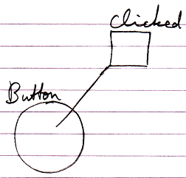

Events Main Concepts

Event
The main notation of an event is as follows:

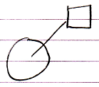

It shows an object with an event procedure / event command / event implementation associated with it.

Event Connector
When an event procedure is not filled in, you will only see the event as a connector:

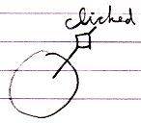

The reason for displaying it like this is that connectors usually look like the result of the system call, but then as a loose end.

Event Raising
The object can raise the event. If you only see the interface of the object you will usually not see this, but if you can see the implementation of the object, its raising the event will look as follows:

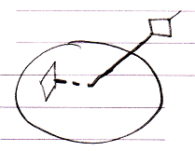

Call to a Parent
An event is a way for an object to call its parent. So this is what that looks like:

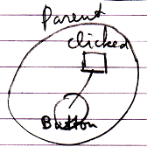

This is the reason why events are displayed like this in the diagram: it is like a child calling a parent.

Event Procedure & Connector
When an event procedure is present, the connector to the event procedure is still available so that other procedures can be tied to the event:

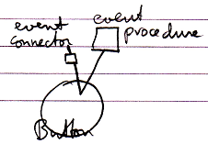

Event Situations
Several situations are possible in case of events. Events are multi-cast, meaning that multiple commands in multiple objects can run in response to the event. Also, a child object is not the only object you can pick up events from. You can also pick up events from deeper objects.

Multi-Cast Events
An event can be picked up by multiple parent objects when they both have a reference to the event-casting object and they both define an event command:

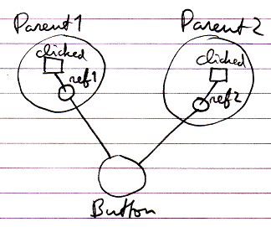

Multi-Cast in Same Parent
Multiple commands can be bound to an event, even when they both are defined inside the same parent object:

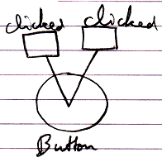

Event with Parameters
Events can have parameters. Here is an example of an event with a parameter.

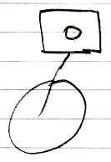

Event From Deeper Object
A child object is not the only object you can pick up events from. You can just as easily pick up events from a deeper object.

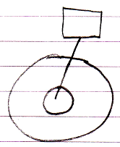

Explicit Implementation of Event Object
The concept of events is nothing more than a combination of constructs: an array of command references, a command interface and supporting the command interface, registering the command inside the array of command references and then calling all the commands in the array at specific times.

Explicitly drawing out the event concept using constructs mentioned above, the picture would look like this:

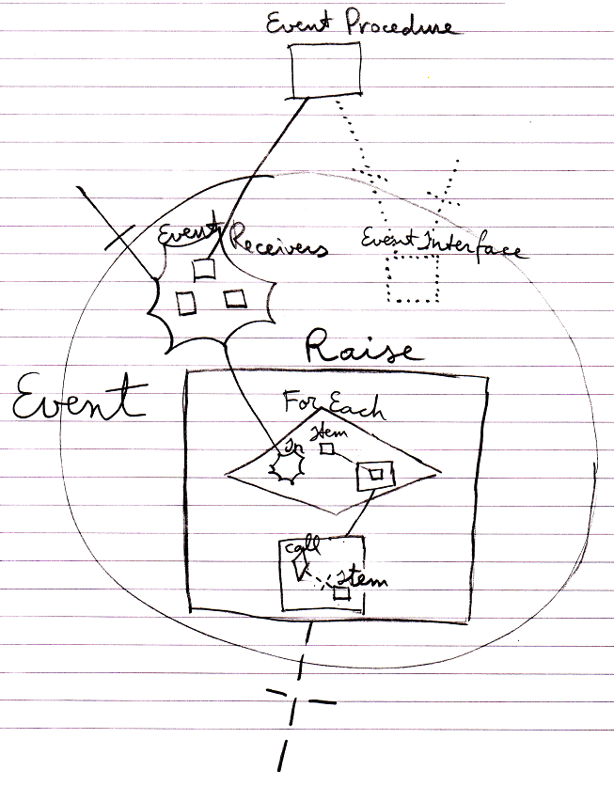

That is the way Event objects are internally implemented.

What you see is the registered event implementation (at the top), the collection of event recievers, the event interface, the Raise command and its implementation that loops through the event receiver commands and calls each of them.

Note that even though the concept is that parents can pick up messages from children, it is not the parents that are registered, but the event procedures that are registered.

Even though the event concept is just a combination of other constructs, it is such an important concept, that the new computer language explicitly defines it as a sepate construct with its own notation.

Explicit Interface of Event Object
The previous article showed how the implementation of an event object explicitly looks. The interface of an Event object, so the part that other object interact with, looks as follows:

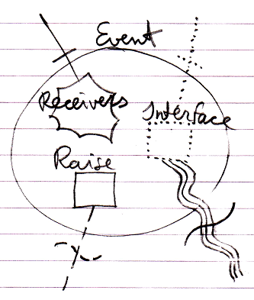

The connectors at the top of the picture are the members that the event receiver will interact with: it will register its command as a Receiver and it will implement the command Interface.

The connectors at the bottom of the picture are the members that the event sender will interact with: it will call the Raise command of the event and it will also define the data that will form the command Interface of the event.

Event Interface Reference
An event command will always implement an interface specified by the Event object. But if you want to express a command’s implementing the event interface without actually being tied to the event, it would look like this:

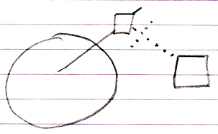

So the event connector is there and the command’s interface reference is tied to the event connector.

System Events
Without even defining any objects or class libraries, there are already a lot of standard events you can use. In most situations these will suffice.

They are events mostly related to changes to the data. Any type of change to the data can be picked up as an event.

More specifically: each system command has an event going off before it is executed and an event going off after it is executed: an Execting event (before) and an Executed event (after).

Derived from this comes the concept of being able to pick up a Value Set command going off. This event is called the Value Changed event. Picking up an event before the value is set also makes you able to cancel that change before it even happened. In case of the Value aspect this is the Value Changing event. So you have the opportunity to cancel a system call altogether.

Any other event of a call to a system command, such as Add, Remove and Execute can be picked up, before or after it happened, and could be cancelled.

Below is an overview of all events that derive from this concept. This results in a big list of standard events, varying in aspect, read/write direction and the before and after events. Something to denote is that Changed events are the ones most commonly used.

Changed Events
Value Changed
Object Changed
Class Changed
Name Changed
Data Changed
Interface Changed
Interface Merged Changed
Clone Written

Changing Events
Value Changing
Object Changing
Class Changing
Name Changing
Data Changing
Interface Changing
Interface Merged Changing
Writing Clone

Get Events
Getting Reference
Reference Gotten
Getting Object
Object Gotten
Getting Reference-Class
Reference-Class Gotten
Getting Object-Class
Object-Class Gotten
Getting Value
Value Gotten
Cloning
Cloned
Getting Name
Name Gotten
Getting Data
Data Gotten
Getting Reference-Interface
Reference-Interface Gotten
Getting Object-Interface
Object-Interface Gotten
Getting Interface Merged
Interface Merged Gotten

Use Events
Reference Used As Object
Using Reference As Object
Using As Class
Used As Class
Using Reference As Class
Reference Used As Class
Using As Interface
Used As Interface
Using Reference As Interface
Reference Used As Interface

List Events
Added (used more)
Adding (used less)
Removing (used more)
Removed (used less)
Storage Count Changed
Storage Count Changing

Execution & Existence Events
Executed
Executing
Created
Creating
Annulled
Annulling

Pointer to Pointer Events
Perhaps the different overloads for pointer-to-pointer situations should have separate events as well, but this depends on design choices and this issue will be left open for now.

System Events in Normal Notation
System can be displayed with the normal event notation, examples of which you will find below.

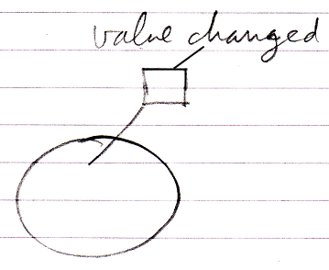

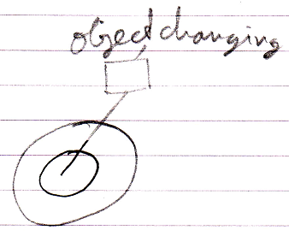

Simplified System Event Notation
System events can also be displayed using a simpler notation that uses line types to denote the aspect, and leaves out the aspect out of the displayed event name.

In the matrix below, reference-bound aspects are displayed with a parent around the event source and object-bound aspects are displayed without a parent around the event source.

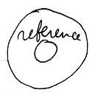

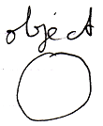

(It is not sure whether this will adequately disambiguate in practice. Hopefully using the diagram concept of automatic containment it will turn out not to be ambiguous, but that is not sure yet.)

Here follow the simplified notations for all the system events.

Reference Aspect

Getting Reference | Reference Gotten
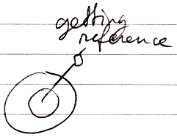 | 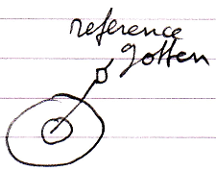

Object Aspect

Object Changed | Object Changing | Object Gotten | Getting Object
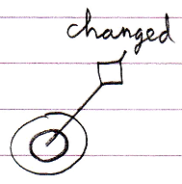 | 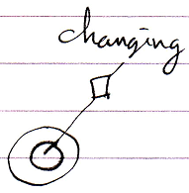 | 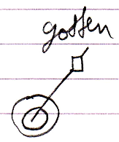 | 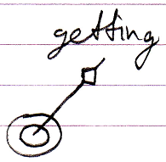
Reference Used As Object | Using Reference As Object
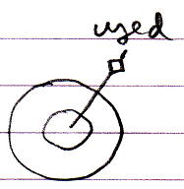 | 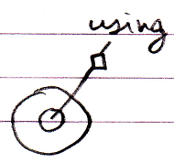

Class Aspect

Class Changed | Class Changing
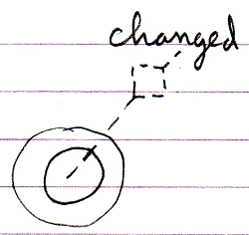 | 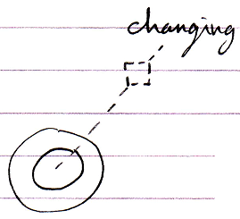
Used As Class | Using As Class | Reference Used As Class | Using Reference As Class
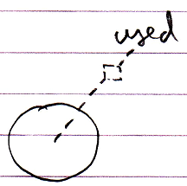 | 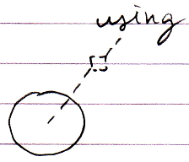 | 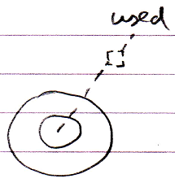 | 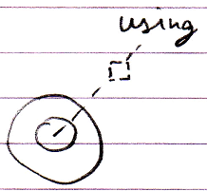
Reference-Class Gotten | Getting  Reference-Class | Object-Class  Gotten | Getting  Object-Class
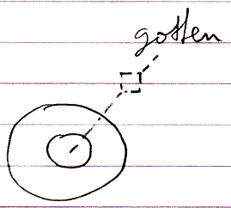 | 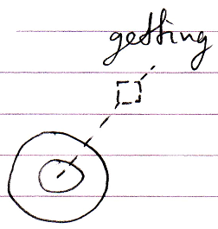 | 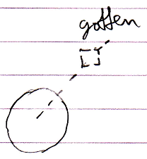 | 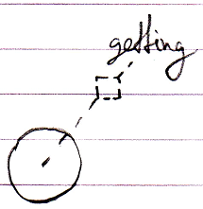

Interface Aspect

Interface Changed | Interface Changing
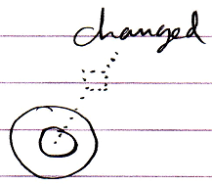 | 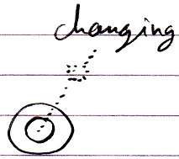
Used As Interface | Using As Interface | Reference Used As Interface | Using Reference As Interface
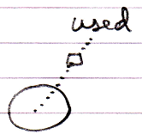 | 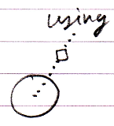 | 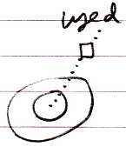 | 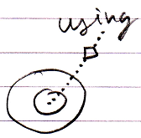
Reference-Interface Gotten | Getting Reference-Interface | Object-Interface Gotten | Getting Object-Interface
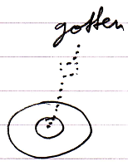 | 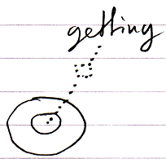 | 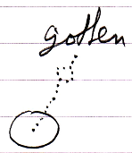 | 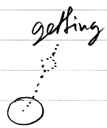

Interface Merged Aspect

Interface Merged Changed | Interface Merged Changing | Getting Interface Merged | Interface Merged Gotten
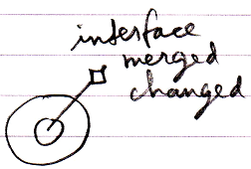 | 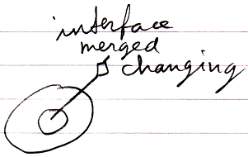 | 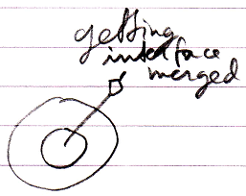 | 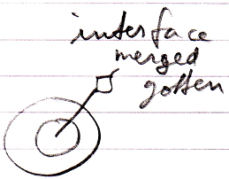

Value Aspect

Value Changed | Value Changing | Getting Value | Value Gotten
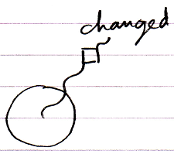 | 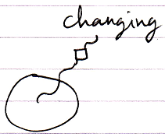 | 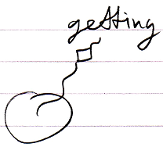 | 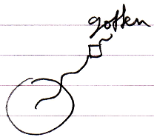

Clone Aspect

Clone Written | Writing Clone | Cloned | Cloning
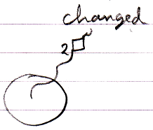 | 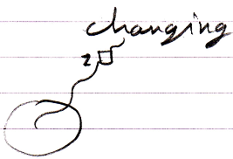 | 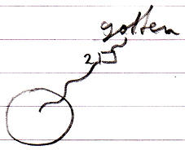 | 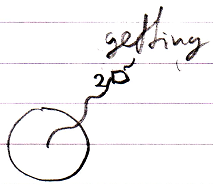

Data Aspect

Data Changed | Data Changing | Data Gotten | Getting Data
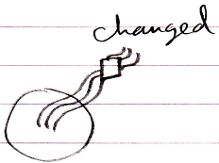 | 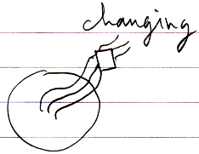 | 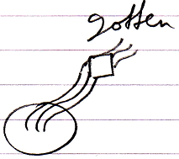 | 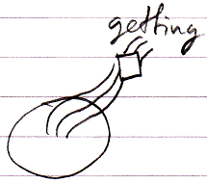

Name Aspect

Name Changed | Name Changing | Getting Name | Name Gotten
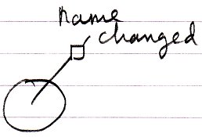 | 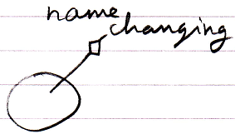 | 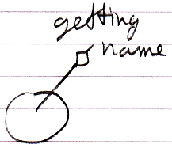 | 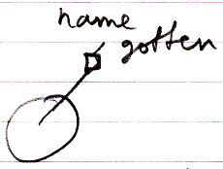

List Aspect

Added | Adding | Removing | Removed
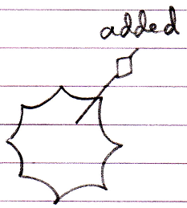 | 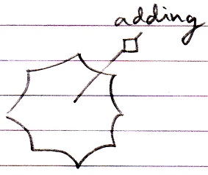 | 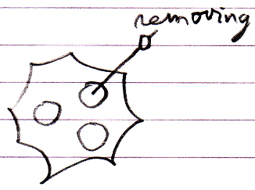 | 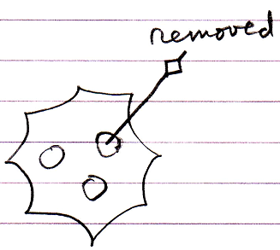
Storage Count Changed | Storage Count Changing
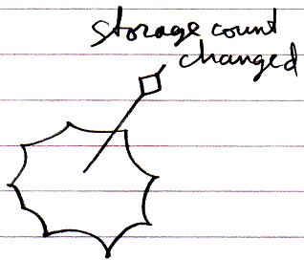 | 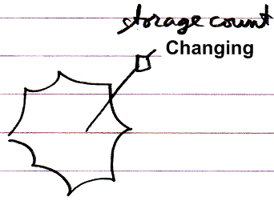

Execution Aspect

Executed | Executing
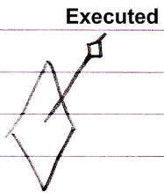 | 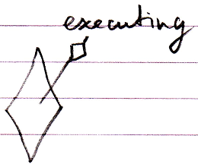

Existence Aspect

Created | Creating | Annulled | Annulling
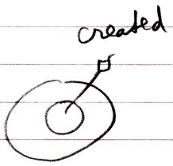 | 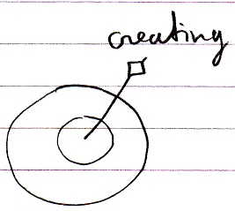 | 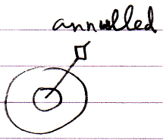 | 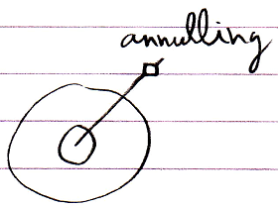

Some aspects have no associated line type, so they are not shown with a simplified notation, but with the normal notation. The above are the connectors, but the actual event commands look almost the same, but then without the loose end at the top.

System Event Parameters
System events have parameters. First of all they have the This parameter, which identifies which object something’s happening to.

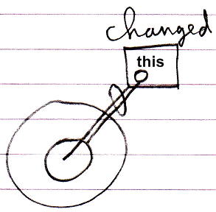

This can be an Object, but also for instance a Related Item.

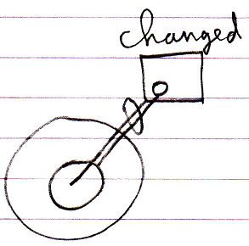 | 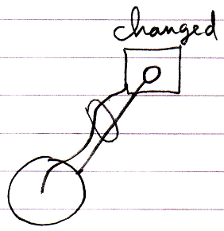
The This parameter is a Related Item | The This parameter is an Object

Second of all for systems events that announce something is about to happen, usually have a Value parameter which indicates which value is about to be assigned and also a Cancel Boolean parameter to be able to assign the value True to, to cancel the event.

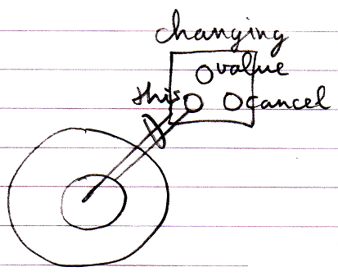

The List and Existence aspects have additional event parameters.

The Creating event have a Class and Interface parameter, which indicate which class or interface the new object will have.

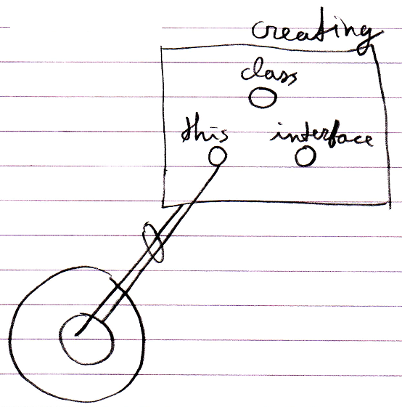

The Adding event has an Item parameter (an Object).

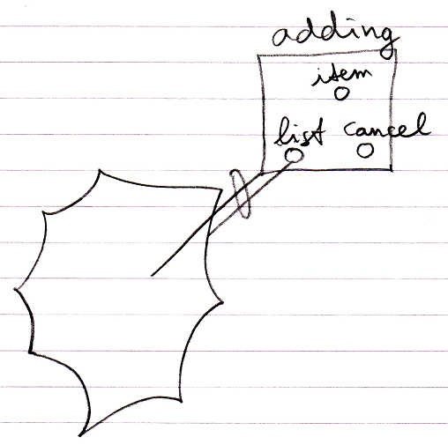

And the Added event has a List Item parameter (a Related List Item)

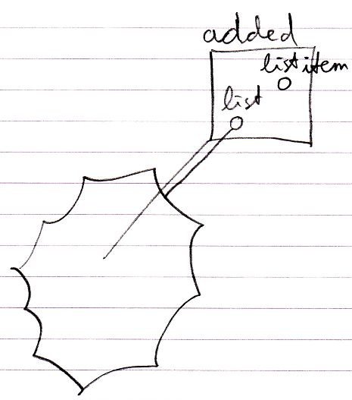

The Clone aspect’s events also have a Depth parameter.

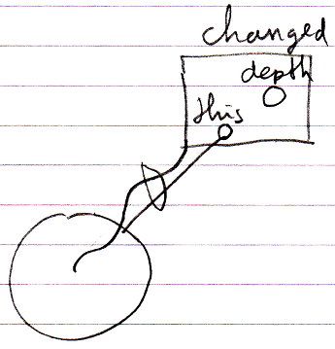

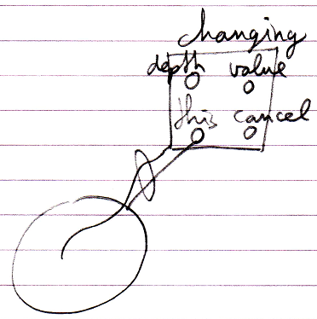

Possibly a Changed event will also contain the Previous Value parameter.

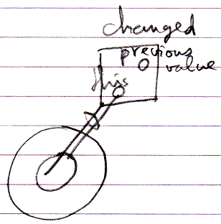

In the earlier introduced connector notation, parameters are not shown. But the parameters are shown in the event implementations.

System Event Design Choices
The names used for the events might not be the eventual names. For instance a more simplified design might simply let all system commands have a Executing and Executed event, instead oof inventing different names for the different events, so that Value Changed is named Value Set . Executed. In another design choice you might not call it the Executing and Executed event, but the Before and After event, or the Happening and Happened events, or the Pre-Extension and Post-Extension events.

This does not change the concept. These are all just benign design choices. You could also call it Value Will Change instead of Value Changing, this is not really the point. It does not change the concept.

The concept is still derived from the fact that you can pick up the Executing and Executed event from any command, including all system commands.

Other design choices that could be made are that other aspect’s changed events may very well all derive from the Value Changed event. And the Class and Interface aspects’ events might all derive from the Object Changed event.

Qualified Event Names
If a Value Changed event from an object My Object . Sub Object is implemented, the event implementation in text code may get a qualified name as follows:

My Object _ Sub Object _ Value Changed

Interaction Events
Apart to system events, the next most commonly used group of events may very well be the interaction events.

Interaction events are events that occur when a user for instance clicks a button, or double clicks or presses a keyboard key.

This type of event is more of a controls concept than a coding concept, but they are mentioned here anyway, because they are such a common use of events

Below you will find a simplified overview of the most common interaction events.

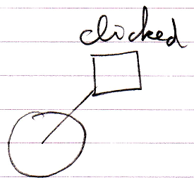 | 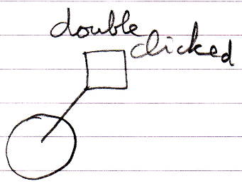
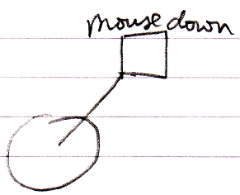 | 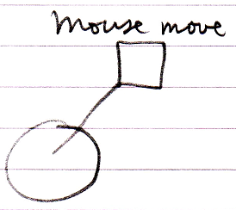 | 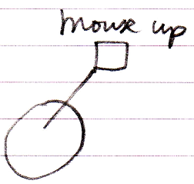
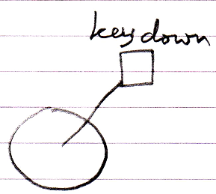 | 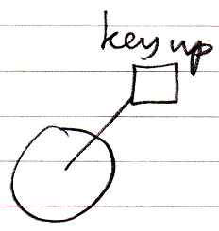

Black Boxing Events
Details about black boxing are covered in the chapter Black Boxing.

However, two situations are explicitly denoted here:

- Making events Private
- Accessing the Privates of an event parameter

Just like any other member of an object, events can also be made Private. In that case only Friend objects can pick up this event. Below you will find the involved notations. Details are not covered. More information about black boxing can be found in the Black Boxing chapter.

Public Event  Connector | Friend Event  Connector | Private Event  Connector
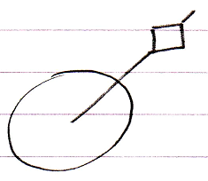 | 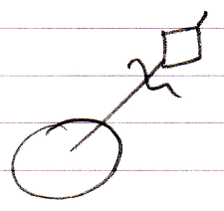 | 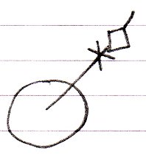
Public Event  Connection | Friend Event  Connection
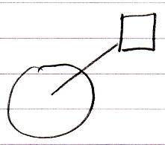 | 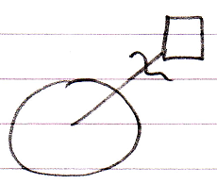 | –

There are two reasons why the Public event connector does not get an access mark: Public is sort of the default, and the event connection is outward so it does not need an access symbol. The others do need an access mark, because it is the only way to express the access modification.

The second black boxing situation to be explicitly mentioned is accessing the Privates of an event parameter. By default you only get to access the Public members of an event parameter. This is what makes it the black box principle.

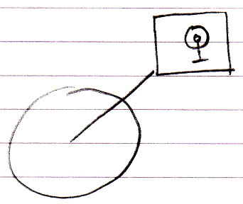

To be able to access the Private members of the event parameter, the event procedure must be declared Friend of the event parameter.

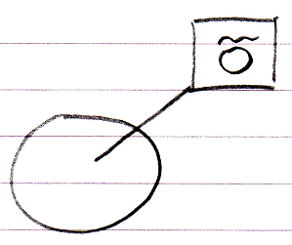

Then the event procedure can access the Private members of the event parameter:

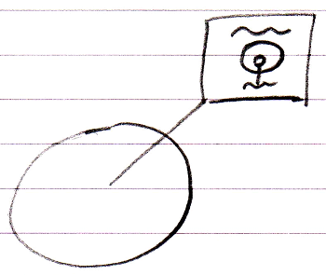

The Friend declaration is an agreement between the event sender and the class of the event parameter. The Friend declaration is part of the event interface, defined by the event sender. So the event receiver can not just declare itself Friend of the event parameter whenever it feels like it.

Event Alternatives
An event is a means for a child to call the parent. The Events concept works well for this. But there are alternatives for a child to call a parent. A simple command reference would do as well, only this does not allow multi-cast events.

Another alternative is that the child defines an interface, that the parent must support, the parent implements the interface, and the child calls upon the interface of the parent. If you want this to work in a multi-cast situation, you have to program the multi-cast functionality yourself pretty much the same way as an event object implements it (see Explicit Implementation of Event Object). Just using standard events might be an easier solution.

